Task 1
- sibusiso@sibusiso-Inspiron-15-3573:~$ ls
Desktop Downloads Music Public Videos
Documents examples.desktop Pictures Templates

#ls list all elements in the directory you in.

- sibusiso@sibusiso-Inspiron-15-3573:~$ pwd
/home/sibusiso

#pwd prints out the directory you currently working

- sibusiso@sibusiso-Inspiron-15-3573:~$ mkdir workspace

- sibusiso@sibusiso-Inspiron-15-3573:~$ cd workspace
sibusiso@sibusiso-Inspiron-15-3573:~/workspace$ ls

- sibusiso@sibusiso-Inspiron-15-3573:~/workspace$ touch README.md

- sibusiso@sibusiso-Inspiron-15-3573:~/workspace$ cp README.md CHANGELOG.md
sibusiso@sibusiso-Inspiron-15-3573:~/workspace$ ls
CHANGELOG.md README.md

Task 2
- sibusiso@sibusiso-Inspiron-15-3573:~/workspace$ touch exercise.md
sibusiso@sibusiso-Inspiron-15-3573:~/workspace$ ls
CHANGELOG.md exercise.md README.md
sibusiso@sibusiso-Inspiron-15-3573:~/workspace$ mv exercise.md /tmp
sibusiso@sibusiso-Inspiron-15-3573:~/workspace$ cd /tmp
sibusiso@sibusiso-Inspiron-15-3573:/tmp$ ls
config-err-gfwNAf
exercise.md
sibusiso@sibusiso-Inspiron-15-3573:~$ rm /tmp/exercise.md
sibusiso@sibusiso-Inspiron-15-3573:~$ cd /tmp
sibusiso@sibusiso-Inspiron-15-3573:/tmp$ ls
config-err-gfwNAf

Task 3
- sibusiso@sibusiso-Inspiron-15-3573:~/workspace$ touch umuzi.md recruits.md cohort.md
sibusiso@sibusiso-Inspiron-15-3573:~/workspace$ ls
CHANGELOG.md cohort.md README.md recruits.md umuzi.md
- sibusiso@sibusiso-Inspiron-15-3573:~/workspace$ cat > umuzi.md
Umuzi is a great place with amazing people and is filled withalot of creatives that you can learn from and gain skills forthe future. The working environment is very accommodating and friendly cause you reach out to anyone for assists and they wouldn't hesitate to share they knowledge and experiences.sibusiso@sibusiso-Inspiron-15-3573:~/workspace$ cat > recruits.md
I am a Data Science recruit who is still new in the tech department and wish to gain alot of knowledge about data science and the entire field itself. Being a new recruit at anysibusiso@sibusiso-Inspiron-15-3573:~/workspace$ cat > cohort.md
At Umuzi we are divided into cohorts which justifies the time you've been at the organisation. There are 18 Cohorts at Umuzi and soon to be 19 later in the year which will be the youngest. I am currently in cohort 17 and it's amazing cause I've met thee most amazing people and intelligent individuals that have the same ambition as I am.

- sibusiso@sibusiso-Inspiron-15-3573:~/workspace$ cat umuzi.md recruits.md cohort.md
Umuzi is a great place with amazing people and is filled withalot of creatives that you can learn from and gain skills forthe future. The work and friendly cause you reach out to anyone for assists and they wouldn't hesitate to share they knowledge and experiences.I am a Data Science recruit who is still new in the tech department and wish to gain alot of kdge about data science and the entire field itself. Being a new recruit at any organisation is very scary but it all starts with you in having to socialise and adapt in order to make contacts and take someone with you when you've reached your end goal.At Umuzi we are divided into cohorts which justifies the time you've been at the organisation. There are 18 Cohorts at Umuzi and soon to be 19 later in the year which will be the youngest. I am currently in cohort 17 and it's amazing cause I've met thee most amazing people and intelligent individuals that have the same ambition as I am.

- sibusiso@sibusiso-Inspiron-15-3573:~/workspace$ cat umuzi.md recruits.md cohort.md | sort > summary.md
sibusiso@sibusiso-Inspiron-15-3573:~/workspace$ cat summary.md
Umuzi is a great place with amazing people and is filled withalot of creatives that you can learn from and gain skills forthe future. The work and friendly cause you reach out to anyone for assists and they wouldn't hesitate to share they knowledge and experiences.I am a Data Science recruit who is still new in the tech department and wish to gain alot of kdge about data science and the entire field itself. Being a new recruit at any organisation is very scary but it all starts with you in having to socialise and adapt in order to make contacts and take someone with you when you've reached your end goal.At Umuzi we are divided into cohorts which justifies the time you've been at the organisation. There are 18 Cohorts at Umuzi and soon to be 19 later in the year which will be the youngest. I am currently in cohort 17 and it's amazing cause I've met thee most amazing people and intelligent individuals that have the same ambition as I am.

- sibusiso@sibusiso-Inspiron-15-3573:~/workspace$ cat >> summary.md
The End
sibusiso@sibusiso-Inspiron-15-3573:~/workspace$ cat summary.md
Umuzi is a great place with amazing people and is filled withalot of creatives that you can learn from and gain skills forthe future. The work and friendly cause you reach out to anyone for assists and they wouldn't hesitate to share they knowledge and experiences.I am a Data Science recruit who is still new in the tech department and wish to gain alot of kdge about data science and the entire field itself. Being a new recruit at any organisation is very scary but it all starts with you in having to socialise and adapt in order to make contacts and take someone with you when you've reached your end goal.At Umuzi we are divided into cohorts which justifies the time you've been at the organisation. There are 18 Cohorts at Umuzi and soon to be 19 later in the year which will be the youngest. I am currently in cohort 17 and it's amazing cause I've met thee most amazing people and intelligent individuals that have the same ambition as I am.
The End

Task 4
- sibusiso@sibusiso-Inspiron-15-3573:~$ locate umuzi
/home/sibusiso/workspace/umuzi.md

- sibusiso@sibusiso-Inspiron-15-3573:~$ locate umuzi > search_result
sibusiso@sibusiso-Inspiron-15-3573:~$ cat search_result
/home/sibusiso/workspace/umuzi.md
Task 5
- sibusiso@sibusiso-Inspiron-15-3573:~$ cd Documents
sibusiso@sibusiso-Inspiron-15-3573:~/Documents$ touch pad.md
sibusiso@sibusiso-Inspiron-15-3573:~/Documents$ ls
Exercises.odt pad.md

- sibusiso@sibusiso-Inspiron-15-3573:~$ cd Desktop
sibusiso@sibusiso-Inspiron-15-3573:~/Desktop$ mkdir work
sibusiso@sibusiso-Inspiron-15-3573:~/Desktop$ ls
work

- sibusiso@sibusiso-Inspiron-15-3573:~/Desktop$ cp ../Documents/pad.md pad_copy.md
sibusiso@sibusiso-Inspiron-15-3573:~/Desktop$ ls
pad_copy.md work

- sibusiso@sibusiso-Inspiron-15-3573:~$ locate updatedb
/etc/updatedb.conf
/etc/alternatives/updatedb
/etc/alternatives/updatedb.8.gz
/usr/bin/updatedb
/usr/bin/updatedb.mlocate
/usr/share/man/man5/updatedb.conf.5.gz
/usr/share/man/man8/updatedb.8.gz
/usr/share/man/man8/updatedb.mlocate.8.gz

- sibusiso@sibusiso-Inspiron-15-3573:~$ cd -
/home/sibusiso/Desktop

- sibusiso@sibusiso-Inspiron-15-3573:~$ locate pad_copy.md
/home/sibusiso/.local/share/Trash/files/pad_copy.md
/home/sibusiso/.local/share/Trash/info/pad_copy.md.trashinfo
/home/sibusiso/Desktop/pad_copy.md

Task 6
- sibusiso@sibusiso-Inspiron-15-3573:~$ find -name *pdf
./Downloads/Group 3 Research & User Interviews.pdf
./Downloads/Group Three Make Umuzi Better _ Portfolio Piece final_version.pdf

- sibusiso@sibusiso-Inspiron-15-3573:~$ find -name pdf >> pdf_result

- sibusiso@sibusiso-Inspiron-15-3573:~$ find -mtime -1
./.local/share/gnome-shell
./.local/share/gnome-shell/application_state
./cat
./.ICEauthority
./Desktop
./Desktop/pad_copy.md
./Desktop/work
./search_result
./Downloads
./search_results.md
./pdf_resul

Task 7
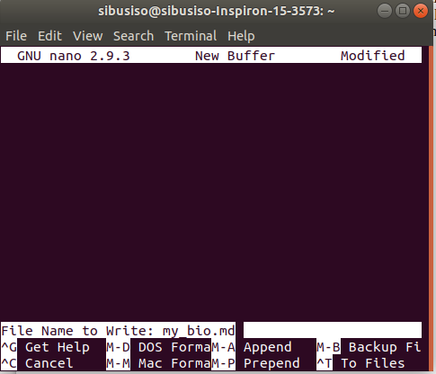
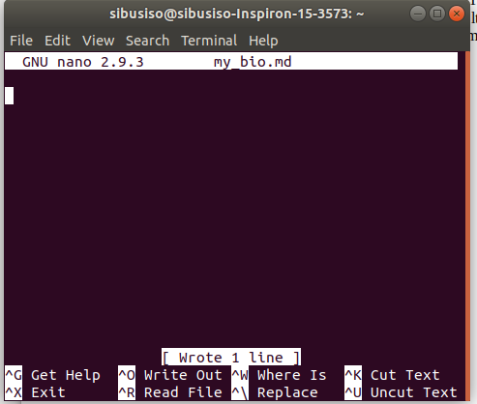

- sibusiso@sibusiso-Inspiron-15-3573:~$ nano
sibusiso@sibusiso-Inspiron-15-3573:~$ ls
cat Downloads my_bio.md Public Templates
Desktop examples.desktop pdf_result search_result Videos
Documents Music Pictures search_results.md workspace

- sibusiso@sibusiso-Inspiron-15-3573:~$ mv my_bio.md my_files
sibusiso@sibusiso-Inspiron-15-3573:~$ cd my_files
sibusiso@sibusiso-Inspiron-15-3573:~/my_files$ ls
my_bio.md

